matlab experiment 3 part III
PREPARED BY
Tyler Long
In partial fulfillment of the requirements for
ECET 4610
PREPARED BY:
APPROVED BY:
October 19, 2008
SOUTHERN POLYTECHNIC STATE UNIVERSITY
Introduction:

For Part III of Lab 3, we were to find the complete behavior (complete time response) of the Antenna Azimuth Position Control System located in the front of the Control System Engineering book. We will first look at the system with the given Block Diagram Parameters and assuming a K value of 1. We will then look at a different value of K (Preamplifier value) and see how the system reacts another way.

Source Code:

For the Antenna Azimuth Position Control System, the following source code was written in Matlab in order to show the complete time response requested:

%This program will be called Antenna Azimuth Position Control System
%Date Programmer Description of change
%=== ========== =====================
%10-19-08 Tyler Long

%Input Parameters
Kpot= input('Enter the Potentiometer value for Kpot: '); %Potentiometer
K= input('Enter the Preamplifier value for K: '); %Preamp
K1= input('Enter the Power amplifier value for K1: '); %Power amp
a= input('Enter the Power amplifier value for a: '); %Power amp
Km= input('Enter the Motor and load value for Km: '); %Motor and load
am= input('Enter the Motor and load value for am: '); %Motor and load
Kg= input('Enter the Gears value for Kg: '); %Gears

%Transfer Function
num= Kpot*K*K1*Km*Kg;
den= [1,(am+a),(am*a),(Kpot*K*K1*Km*Kg)];

%Step response
[y,x,t] = step(num,den);
plot(t,y)
xlabel('Time in seconds');
ylabel('Displacement');
title ('Azimuth Antenna - Tyler Long');
grid on;

Locate within the above source code the section labeled “Transfer Function.” Here the numerator and denominator of the transfer function are defined. These two were predetermined using hand calculations which can be located within Appendix A.

Simplification:

Before simplification, the book depicts the Antenna Azimuth block diagram as Figure 1 below:

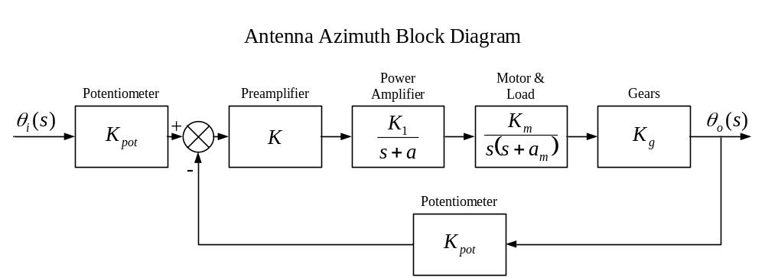
Figure 1: Antenna Azimuth Block Diagram

Once the transfer function from the book was simplified, the system was obtained in terms of the parameters given in Figure 2 below:

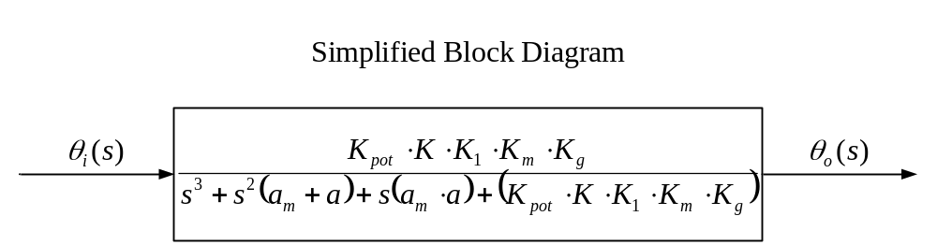
Figure 2: Simplified Block Diagram

The function as depicted within Figure 2 was the one used within the source code for determining the complete time response of the system.

Configuration 1- K=1:

The following parameters were used initially in order to see how the system operates with a Preamplifier value of K=1:

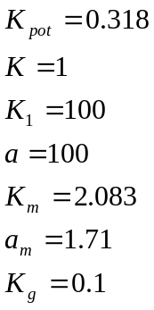

Figure 3 below is the graph of the inputs listed above:

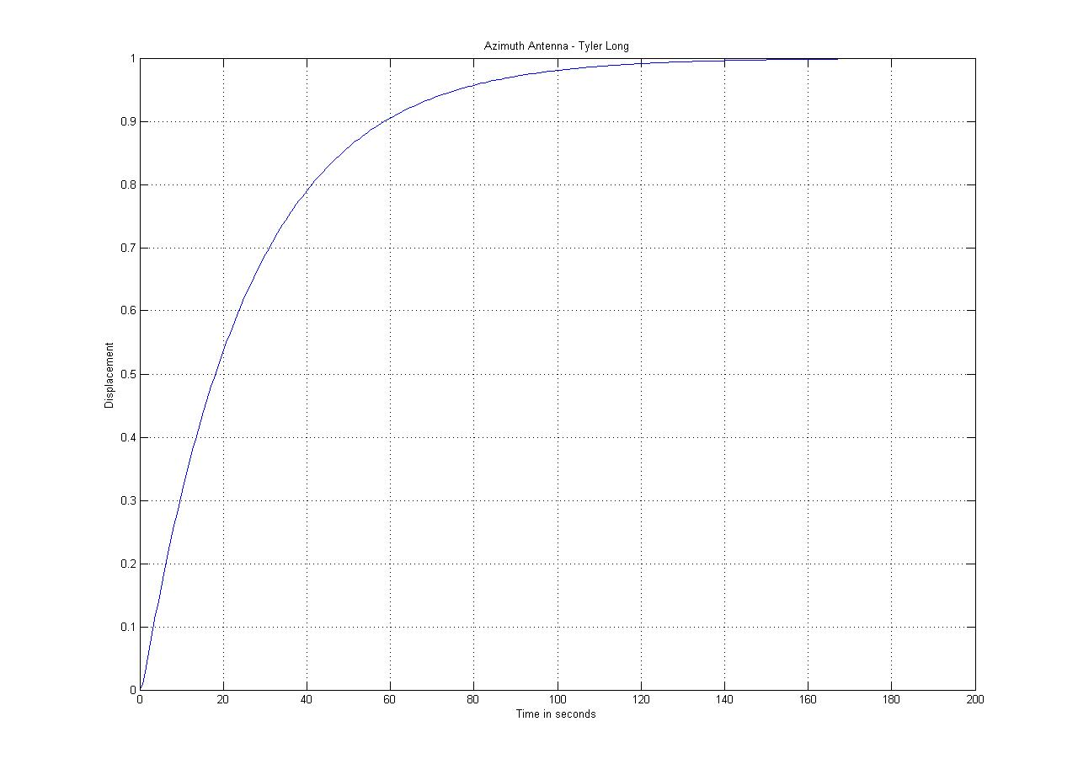
Figure 3: Response for K=1

Figure 3 shows an overdamped system which has a settling time of around 140 seconds. An overdamped system is preferred with a mass of this size. Having an antenna swinging back a forth under an underdamped system trying to reach steady state might tear up the gears. We can, however, minimize the time it takes to reach steady state by increasing the value of K to a certain degree. See the next configuration for how this change will affect the system.

Configuration 1- K=4:

The following parameters were used in order to see how the system operates with a Preamplifier value of K=4:

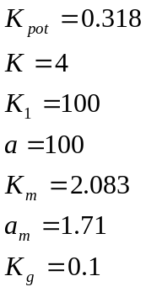

Figure 4 below is the graph of the inputs listed above:

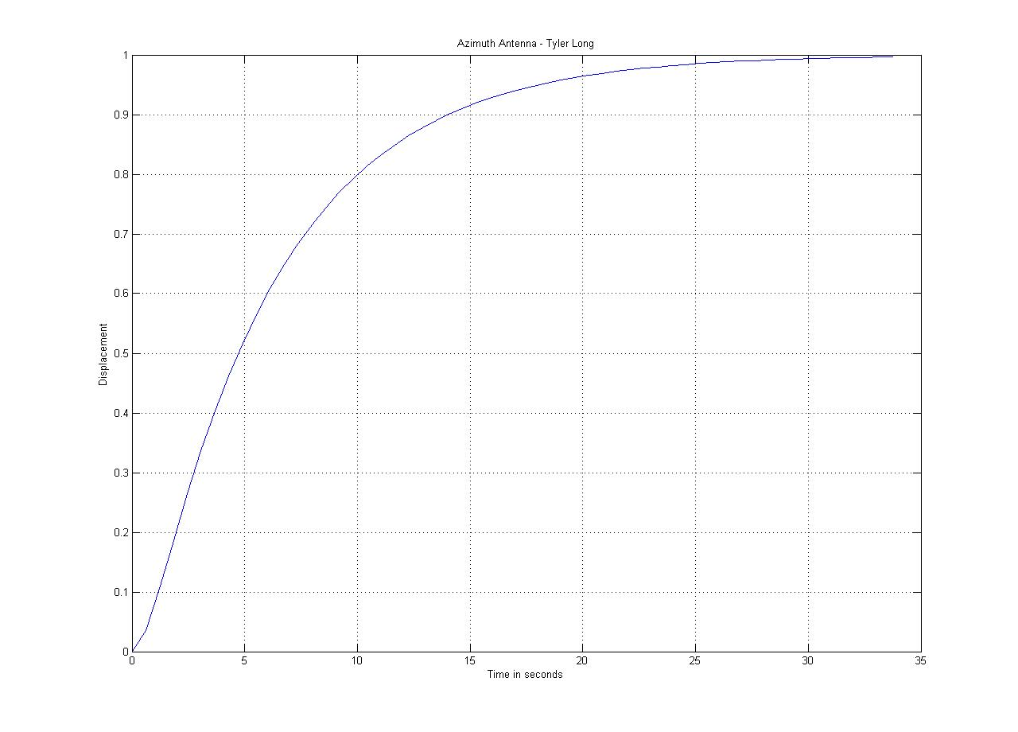
Figure 4: Response for K=4

Figure 4 shows an overdamped system which has a settling time of around 32 seconds. Compared with Figure 3, Figure 4 reaches its steady state much quicker. Increasing K is proportional to the quickness with which the system reacts.

Conclusion:

With respect to Figure 4, increasing K to around 11.718 would result in a critically damped system. If K was taken higher, an underdamped system would result causing the system to overshoot its steady state value. Both critically damped and underdamped systems might cause a mechanical issue.

With a critically damped or underdamped system, the antenna may accelerate too quickly causing a mechanical failure within the gearing. The motor may also be started too quickly causing an over current fault to take place. Either a bigger motor or stronger gearing would need to be installed which may now cause a cost issue. Thus, having a quick system may not be the best choice in this scenario. There is a balance between speed and reliability which must be accounted for when choosing a value for K.

Appendix A

